**ORDER SUPPLEMENT**

**PRINTED BOARD MANUFACTURING SPECIFICATION**

Sechan Electronics, Inc.

525 Furnace Hills Pike

Lititz, PA 17543

|  |  |  |
| --- | --- | --- |
| **REVISION HISTORY** | | |
| **REV.** | **DESCRIPTION** | **DATE** |
| B | Rewrite, incorporate material requirements and material certifications for printed boards. Incorporate requirements for test and conformance coupon evaluations. Title change. | 1/23/2009 |
| C | Paragraph 2.0, Incorporate newly released IPC 1601 document for PWB packaging; Paragraph 4.6, incorporate IPC-1601 guidance. | 12/7/2010 |
| D | Delete paragraph 5.4 and renumber 5.5, coupons no longer required; Attachment I, delete (b), coupons for SDRL02. | 7/31/12 |
| E | Paragraph 4.2, 2nd bullet, add “if required by PO”. Update packaging requirement for silver immersion finishes. | 3/13/13 |
| F | Add paragraph 5.5; Add J-STD-003 to Applicable Documents. | 3/28/13 |
| G | Paragraph 4.1, change bullet for reference to IPC-SM-840 Class 3 to Class H or FH. | 7/22/13 |
| H | Paragraph 4.1: Add bullets 6 and 9 (non-conductive via fill and foil wrapping) and modify bullet 8. Paragraph 4.2a-g: Add ideal panel size. Paragraph 4.4: rewrite. Paragraph 4.6 renumber as 5.0; Para. 4.6 renumber to 6.0. Paragraph 6.1 rewrite. Paragraph 5.0 renumber to 7.0. Add 7.2.2 and 7.6. | 11/26/13 |

SCOPE

This supplement provides general procurement requirements between Sechan Electronics, Inc. (BUYER) and SELLER for Types 2, 3 or 4 printed board technologies. The intent is to establish a Class 3 (High Reliability Electronic Products) product performance standard that is consistent with the IPC workmanship standards (IPC-A-600, IPC-6011, IPC-6012 and IPC-6013).

APPLICABLE DOCUMENTS

The following documents of the revision at time of this OS release form a part of this supplement to the extent specified herein. Revision applicable at date of BUYER order applies. Other applicable detail product drawings, specifications and requirements will be listed on the face of the BUYER order.

|  |  |
| --- | --- |
| IPC-2221 | Generic Standard for PWB Design |
| IPC-2222 | Design Standard, Rigid Organic Printed Boards |
| IPC-4101 | Specification for Base Materials for Rigid and Multilayer Boards |
| IPC-4103 | Specification for Plastic Substrates, Clad or Unclad, for High Speed High Frequency Interconnection |
| IPC-4202 | Flexible Base Dielectrics for Use in Flexible Printed Wiring |

|  |  |
| --- | --- |
| IPC-4553 | Specification for Immersion Silver Plating for Printed Circuit Boards |
| IPC-6011 | Generic Performance Specification for Printed Boards |
| IPC-6012 | Qualification and Performance Specification for Rigid Printed Boards |
| IPC-6013 | Qualification and Performance Specifications for Flexible Printed Boards |
| IPC-A-600 | Acceptability of Printed Boards |
| IPC-SM-840 | Qualification and Performance of Permanent Polymer Coating (Solder Mask) for Printed Boards |
| IPC-TM-650 | Test Methods Manual |
| IPC-1601 | Printed Board Handling and Storage Guidelines |
| J-STD-003 | Solderability Tests for Printed Boards |

ORDER OF PRECEDENCE

In the event of differences and/or conflict among different requirements, the following order of precedence shall apply:

* The BUYER procurement order
* The master drawing or assembly drawing
* This order supplement
* Other applicable documents

Conflicts and planned resolution shall, however, be identified to the BUYER in writing (e-mail is preferred). To assure consistency in material provided, the BUYER may initiate a revision in the printed board master drawing and incorporate this change in the order structure.

Definitions

|  |  |
| --- | --- |
| CTE | Coefficient Temperature Expansion |
| IPC Class 3 | High Performance Electronic Products. Includes products where continued high performance or performance-on-demand is critical, equipment downtime cannot be tolerated, end-use environment may be harsh, and the equipment must function when required, such as life support or other critical systems. |
| Panel Tool Holes | Locating holes on PWB panel |
| PTH | Plated Through Hole |
| PWB Panel | Multiple printed boards fabricated on a PWB panel for assembly ease. Layout configuration on the panel is optional but must be documented to BUYER. |
| PWB Scoring | Scoring of PWB material for ease of individual PWB removal. Approved scoring methods include either DSS (Double-Side Score) or SSS (Single-Side Score). |
| PWB, Type 2 | Double-sided printed board |
| PWB, Type 3 | Multilayer printed board without blind and / or buried vias |
| PWB, Type 4 | Multilayer printed board with blind and / or buried vias |
| Tg | Glass Transition Temperature |

GENERAL REQUIREMENTS

It is the intent that processes be consistent with normal SELLER operations and practices to the extent possible. However, material selection and process control requirements of this supplement shall be implemented unless a variance is authorized by the BUYER. This QAIS is available on the BUYER web site, [www.sechan.com](http://www.sechan.com) (navigate to Supplier Portal, then select ‘Documents’).

MATERIALS

The timely identification of material selection variances is valued and encouraged. Disposition of these variances shall be documented with mutual concurrence between BUYER and SELLER and shall become part of the printed board configuration baseline.

* It is recognized that drawing requirements (customer and otherwise) may not always specify some materials or that materials specified may be incompatible. Because of this, it is required that the

SELLER review materials selected for this printed board fabrication and that these materials be compatible and consistent with IPC-2222 par. 4 with regard to temperature characteristics (CTE and Tg ). Laminates selected shall have glass transition temperatures (Tg) typically 170C or higher.

* The Pre-impregnated Bonding Layer (Prepreg) shall conform to the types and requirements listed in IPC-4101 and shall be compatible with copper clad laminate, as applicable.
* Adhesives selected shall be compatible and consistent with IPC-2221 par. 4.2.2 and 4.2.3 and IPC-4101, as applicable
* Laminate materials shall be selected from material listed in IPC-4101, IPC-4103 or IPC-4202, as applicable.
* Conductive materials used in the printed board construction shall be in accordance with IPC-2221 par. 4.4 and Table 4-3 for IPC Class 3 product. Conductive materials and printed board exterior finish shall be as required by master drawings and shall be compatible with other materials used in printed board construction.
* Non-conductive via fill on blind and buried vias shall be used unless specified on the print.
* Solder mask coatings and markings shall be compatible with each other and other materials in the printed board and shall be in accordance with IPC-SM-840 using Class H or Class FH materials as required. The preferred solder mask surface finish is ‘matte’.
* It is preferred that when the printed board has via holes, these through ‘via’ holes are tented with solder mask material unless otherwise directed in the board fabrication files.
* Foil wrapping in accordance with IPC-4562 is permissible if the stack-up is not defined in the drawing package.

mechanical / physical properties

* The bow and twist of finished bare printed board product shall not exceed IPC-2221 par. 5.2.4 requirements for Class 3 product. Values are measured consistent with requirements of IPC-TM-650 Method 2.4.22.
* If required by PO, Printed board panelization shall be as required by IPC-2222 and this BUYER order supplement.

1. PTH printed board (or combined SMT / PTH technology) panel shall not be larger than 16” x 16” and shall include a minimum border of 0.4” on at least two parallel sides. The ideal size for Sechan is 15” x 11” and all designs shall be evaluated to fit on this size prior to increasing to the maximum.
2. SMT printed board panel shall not be larger than 16” x 18” and shall include a minimum border of 0.4” on the 16” panel dimension.
3. Refer to Figure 1 for a typical printed board panelization layout.
4. Routed width between printed board and panel shall be 0.100” +/- .005”.
5. Panel tooling holes are required at three locations. Panel tooling holes shall be 0.125” +.003”/ -.000”
6. Fiducials are to be placed on the tooling tabs near the three mounting holes.
7. Pallet break-away tabs shall use either (a) single side score or (b) double side score. All other tab break-away conventions require BUYER approval before use. Refer to Figures 2 and table.
8. BUYER requires electronic media with revisions (as needed) of the selected panelization layout. This layout configuration media shall be provided as early as practical and will become the basis for panelized PWB acceptance. Submit media per requirements of SDRL01.



Figure 1, Typical Panelized Layout

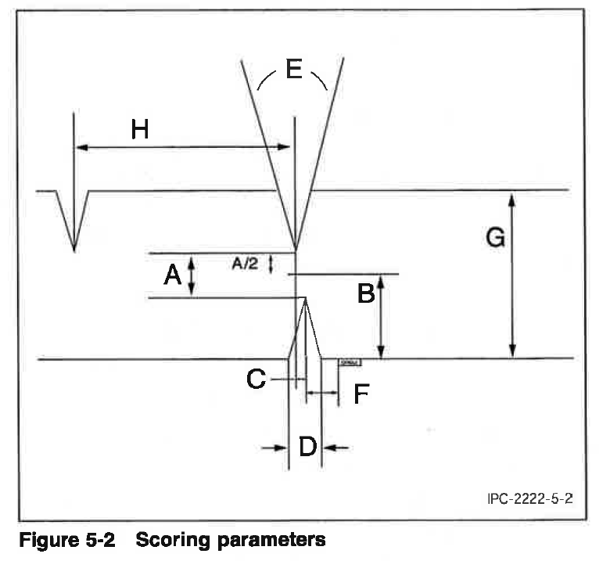

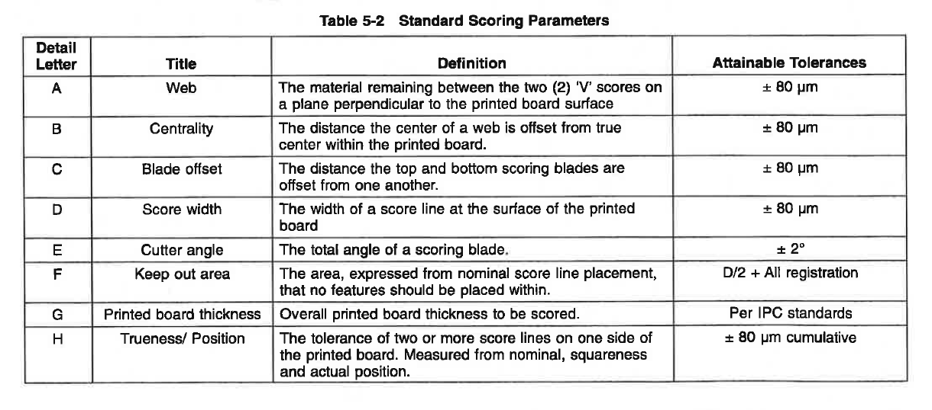

Figure 2, Breakaway Tab Detail (refer to table following)

Printed board workmanship

Printed board workmanship (both external and internal observable characteristics) shall be consistent with IPC Class 3 product performance standards (IPC-A-600, IPC-6011, IPC-6012 and IPC-6013). This criterion will be used as part of the BUYER acceptance process.

TECHNICAL DATA PACKAGE

Sechan shall be provided a written copy, in the SELLER’s format, of any changes to the fabrication data needed to support manufacturing. If BUYER determines that the changes result in a significant contradiction, the BUYER shall provide the SELLER with additional change paper accepting or rejecting the change(s).

1. PRODUCT MARKING AND SERIALIZATION

Each printed board shall be identified and traceable to the SELLER fabrication lot in accordance with IPC-2221 and shall include:

* Printed board part number and revision
* Traceability identification
* Production lot date code
* Manufacturer’s identification

1. PACKING/PACKAGING/LABELING AND SHIPMENT

SELLER selected packing and packaging shall be suitable for the intended purpose, providing proper protection for the Printed board using IPC-1601, paragraph 4 as guidance.

Silver Immersion Finish

SELLER shall package per IPC-4553, Section 3.8. Boards shall be individually packaged immediately after processing. Air shall be vacated from the individually packaged board. Interleave may be used only if it is certain to not react with the silver finish. Desiccant and other silver reactive materials shall not be used.

All Other Finishes

Additionally, each PWB shall be packaged with interleaving material such that the PWB is not in direct contact with an adjacent PWB. The packaging material selected shall not leave residual material on the PWB surface.

Quality assurance

BUYER STANDARD QUALITY REQUIREMENTS

The following BUYER Standard Quality Requirements apply. QR clause language may be found on the BUYER web site at [www.sechan.com](http://www.sechan.com). Navigate to Supplier Portal and then select ‘Documents’.

QR-2 Supplier Quality System

QR-3 Purchase Order Conformance Certification

QR-3.2 Quality Record Retention

QR-3.3 Raw Material Certification

QR-4 Supplier’s Corrective Action System

QR-5 Supplier Configuration Control

QR-6 Sechan QA Visitation Authority

QR-7 Nonconforming Material Disposition

QR-15 Acceptance Test Reports

QR-25 First Piece Inspection Report

QR-32 Printed Wiring Board Fabrication

PRinted Board electrical TEST data

7.2.1 Each printed board lot delivered shall be electrically tested for proper continuity using the BUYER provided documentation (Gerber or CAD extracted netlist or equivalent). Certification to this requirement is required for each deliverable lot; a physical product stamp (or mark) on the printed board is preferred. Submit test certification per SDRL02.

7.2.2 Supplier shall provide a copy of the netlist, or equivalent, used to perform the test that includes the pass/fail values, for reference the first time a board part number is delivered to Sechan.

material CONFORMANCE CERTIFICATION

Each printed board lot delivered shall include material certifications for materials used in PWB fabrication process (refer to paragraph 4.1 above) and QR-3.3. As a minimum, these certifications shall include:

* SELLER and SELLER’s batch lot identification
* Laminate manufacturer’s certification
* Prepreg manufacturer’s certification
* Adhesive manufacturer’s certification
* Other material certifications *if specified in the master drawings*
* Submit material certifications per SDRL02.

PROBLEM INVESTIGATION REPORT

Printed board failures returned to SELLER shall be analyzed for root-cause and corrective action. A Problem Investigation Report (PIR) shall be issued to the BUYER in accordance with SDRL03.

j-std-003 category 3

When Category 3 testing is required by Contract (PO, Drawing, etc.). The SELLER shall provide a report certifying compliance to the requirement for each delivery.

COUPONS

In addition to the IPC-2221 A coupon, Supplier shall generate a B coupon (with input from Sechan as required) in order to characterize and evaluate each blind, buried or filled through hole via. The B coupon is to be designed for registration evaluation. Its construction should insure that both minimum annular ring and minimum spacing between plated holes and circuitry are met. The B coupon shall have a land size that makes this possible, even if that size pad with that particular drilled hole diameter does not exist on the part.

**ATTACHMENT I**

**SUPPLIER DATA REQUIREMENTS LIST**

The following documentation is required. Reports may be submitted in SELLER format; unless otherwise specified, only one (1) copy of each submission is required. All technical data submitted shall be identified with the BUYER order and with the name and address of the SELLER.

|  |  |  |
| --- | --- | --- |
| **ITEM** | **FREQUENCY** | **DESCRIPTION** |
| SDRL01 | Once w/revisions | Electronic media of the selected panelization layout shall be provided. Provide this layout media as early as practical. |
| SDRL02 | Each deliverable lot | LOT ACCEPTANCE DATA including (a) material conformance certifications. |
| SDRL03 | As Required | PROBLEM INVESTIGATION REPORT – Submitted as required |